Leandro Rivera 2226651

Balmer Valencia 2227097

Validación usando el PIM

In Exercises 3-26, use mathematical induction to prove that the statements are true for every positive integer n. (Hint. In the algebra part of the proof, if the final expression you want has factors and you can pull those factors out early, do that instead of multiplying everything out and getting some humongous expression).

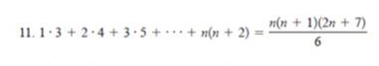

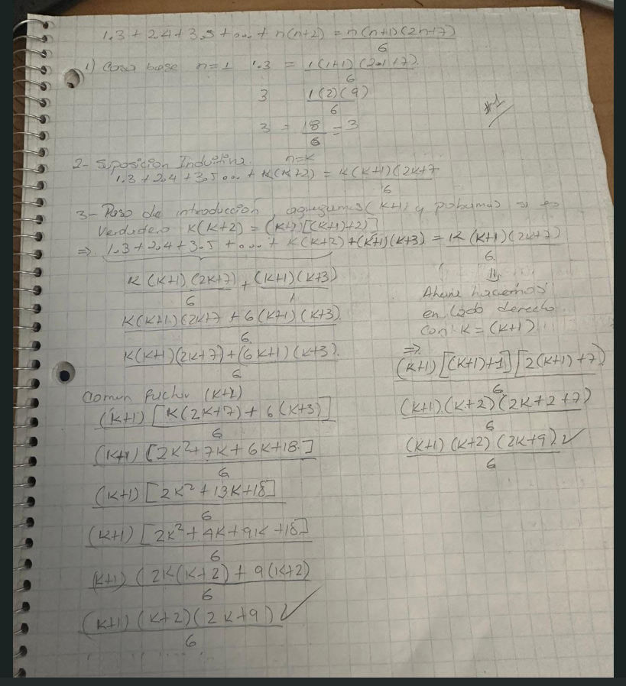

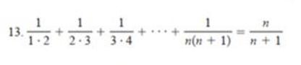

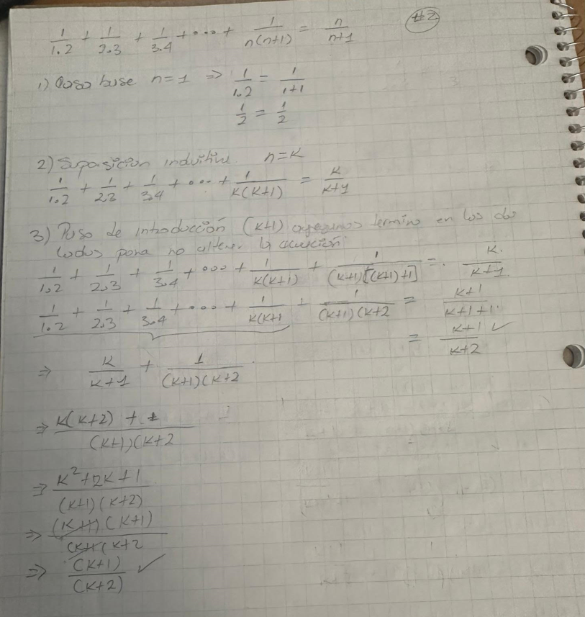

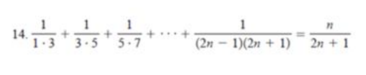

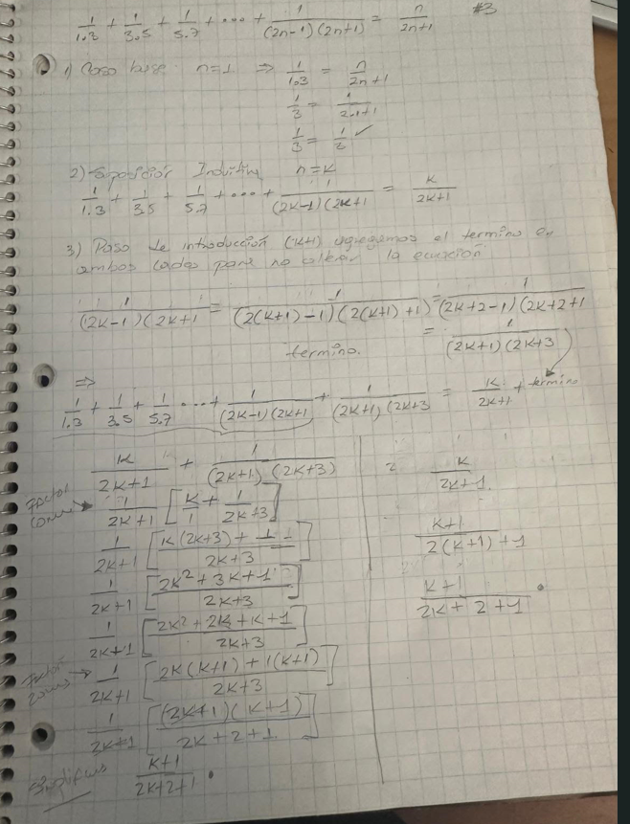

The famous Towers of Hanoi puzzle involves 3 pegs whit n disks of varying sizes stacked in order from the largest (on the bottom) to the smallest (on the top) on 1 of the pegs. The puzzle requires that the disks end up stacked the same way on a different peg; only one disk at a time can be moved to another peg, and no disk can ever be stacked on top of a smaller disk. Informally describe a recursive algorithm to solve the Towers of Hanoi puzzle.

